**Exercise 4: Arrange-Act-Assert (AAA) Pattern, Test Fixtures, Setup and Teardown Methods in JUnit**

**Scenario:**   
You need to organize your tests using the Arrange-Act-Assert (AAA) pattern and use setup and teardown methods.   
Step- 1:

**Write tests using the AAA pattern.**Created java project named AAAPattern

>src>created a java class called Calculator.java  
public class Calculator {

public int add(int a,int b)

{

return a+b;

}

public int subtract(int a,int b)

{

return a-b;

}

}

Step2:

Created a CalculatorTest.java

import org.junit.jupiter.api.Test;

import org.junit.jupiter.api.AfterEach;

import org.junit.jupiter.api.BeforeEach;

import static org.junit.jupiter.api.Assertions.*assertEquals*;

public class CalculatorTest {

private Calculator calculator;

*@BeforeEach*

void setuP()

{

calculator=new Calculator();

System.***out***.println("before each:calculator created");

}

*@Test*

void testAddition()

{

//Arrange-set up the variables

int a=5;

int b=3;

//act -we write logic

int result=calculator.add(a, b);

//assert-verify the results

*assertEquals*(8,result);

}

*@Test*

void testSubtraction()

{

//Arrange

int a=100;

int b=50;

//act

int result=calculator.subtract(a, b);

//assert

*assertEquals*(50,result);

}

*@AfterEach*

void tearDown()

{

calculator=null;

System.***out***.println("after each:calculator set to null");

}

}

Right click on CalculatorTest.java and and click on run as JUnit   
Below is the output that we get when we run  
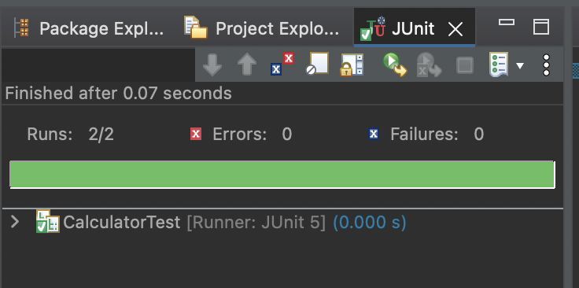

I have clicked on run as JUnit 2 times so it is showing 2 times

